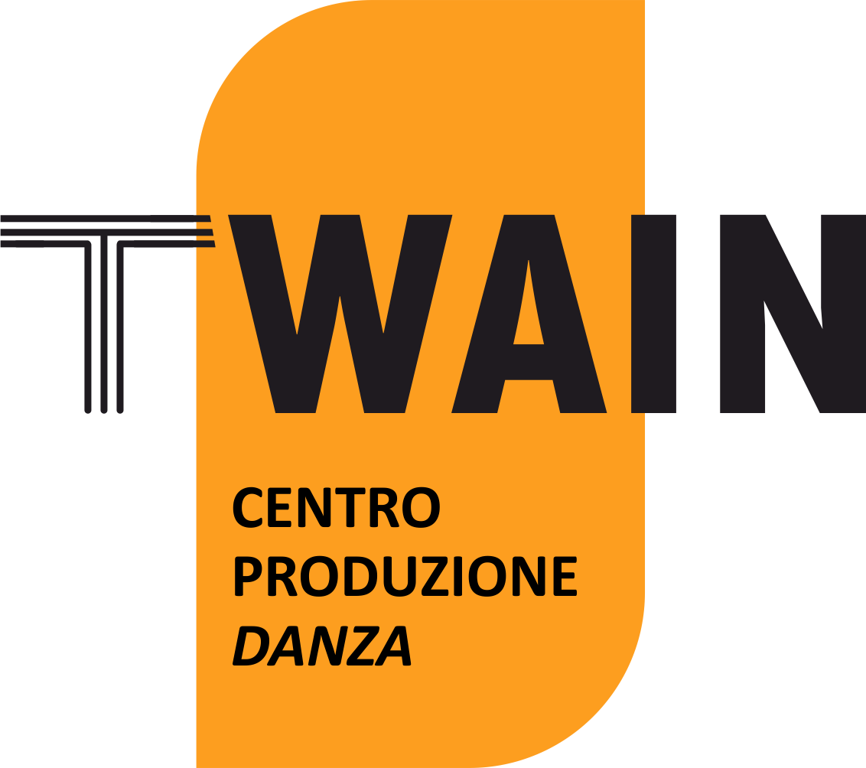

“PREMIO TWAIN_direzioniAltre 2022”
6th edition
APPLICATION FORM

Company/Artist Name
Project title
Name(s) of the author(s)
Place and date of birth of the author(s)
Nominative interpreters
Project Contact Person | Surname
 | First Name
 | Phone
 | E mail
City of origin artist/company
Video link proposed project
Any links to previous works already done
Website or Fb of the Company/Artist
Any stages of work and dates (residencies, previews, presentations of studies) already carried out or to be carried out
Credits
Company name and legal representative name of the subject (association, cooperative, foundation, etc) who will issue an invoice and provide Ex-Enpals usability
Any texts protected by S.I.A.E.
Any music protected by S.I.A.E.
Any choreographies protected by S.I.A.E.

I agree to participate in the Twain_direzioniAltre 2022 Award Call and I declare to accept the conditions set by it.
This form, completed in its entirety, must be delivered together with the material supplied. The signature implies the complete acceptance of the regulations of the Call.
The dates indicated in the announcement may vary depending on the pandemic trend and any restrictions or changes due to government actions.
I declare that I am responsible for the content of the material presented and I authorize its non-profit publication. On the basis of the provisions of Legislative Decree no. 196/2003, the author authorizes the processing of personal data and their use by the organizers for the fulfillment of the obligations inherent to the Call.

Date and Place Signature

